

EHS标识管理制度
EHS Label Management System

内部使用
在使用前，请和文档编写人员确认本文档为最新版本。
未经上海暻熠数据科技有限公司、上海暻耀网络技术有限公司书面许可，其它任何机构或个人不可传阅、引用或复制本文件的内容。

Internal use
Before using, check with the documentation writer to make sure this document is the latest version.
Without the written permission of Shanghai Jingyi Data Technology Co., Ltd., Shanghai Jingyao internet Technology Co., Ltd., no other organization or individual is allowed to circulate, quote or copy the content of this document.

文件编号Documents | IP-PJ-EHS-17
版 本Edition | V1.0
文件维护部门File maintenance department | 上海浦江数据中心
会签部门Document Signing department | 上海浦江数据中心
执行范围Scope of execution | 上海浦江数据中心

文件修订记录
Document Revision Record

版本号  Edition | 版本日期  Date | 修订内容  Revised Content | 修订人员  Revision personnel | 核准员  Approver | 备注  Remarks
V1.0 | 2025-04-16 | 首次修订 | 楚靖岳 | 陆磊

目录Content
1 目的Purpose 4
2 适用范围Scope of Application 4
3 规范性引用文件 Normatively Referenced Documents 4
4 术语和定义Terms and Definitions 5
5 职责Responsibilities 6
5.1 各部门/岗位/业务线All departments/ positions/ business lines 6
5.2 EHS管理负责人EHS officer 6
6 程序Procedures 7
6.1 安全标志Safety Sign 7
6.2 安全标志牌的要求Requirements for safety signs 8
6.3 安全标志牌的型号选用 Selection of models for safety signs 9
6.4安全标志牌的使用要求The usage requirements of safety sign plates 9
6.5 安全标志牌的检查和维修Inspection and Maintenance of Safety Signboards 11
6.6 工业管道标识Identification of industrial pipelines 11
6.7 环境管理相关标识Identification Related to Environmental Management 14
6.8 职业健康相关标识Identification Related to Occupational Health 14
6.9 消防管理相关标识Identification Related to Fire Protection Management 14
6.10 危险化学品相关标识Identification Related to Hazardous Chemicals 14
6.11 电气管理相关标识Identification Related to Electrical Management 14
6.12 沟通与培训Communication and Training 15
7 附件Attachments 15

1 目的Purpose
本制度旨在建立上海暻熠数据科技有限公司、上海暻耀网络技术有限公司（以下简称“上海浦江数据中心”）安全生产责任制度。目标包括确保遵守国家和地方法律法规、国外相关法规、客户要求以及上海浦江数据中心内部要求，明确并落实各岗位人员的安全生产责任，预防和减少生产安全事故的发生，降低运营EHS风险，并促进持续改进。
This system aims to establish the special equipment management process for Shanghai Jingyi Data Technology Co., Ltd., Shanghai Jingyao internet Technology Co., Ltd.. (hereinafter referred to as "SHANGHAI Pujiang Data Center"). The objectives include ensuring compliance with national and local laws and regulations, relevant foreign regulations, customer requirements, and internal requirements of SHANGHAI PUJIANG Data Center, ensuring compliance with special equipment management, reducing operational EHS risks, and promoting continuous improvement.
2 适用范围Scope of Application
适用于上海浦江数据中心，以及所有与EHS有关事项的管理职能。
Applicable to SHANGHAI PUJIANG Data Center and all management functions related to EHS matters.

3 规范性引用文件 Normatively Referenced Documents
《中华人民共和国安全生产法》（2021年修订）
<Work Safety Law of the People's Republic of China>(Revised in 2021)
《中华人民共和国环境保护法》（2014年修订）
<Environmental Protection Law of the People's Republic of China>(Revised in 2014)
《中华人民共和国职业病防治法》 (2018年修订)
<Law of the People's Republic of China on Prevention and Control of Occupational Diseases> (Revised in 2018)
《中华人民共和国固体废物污染环境防治法》（2020年修订）
<Law of the People's Republic of China on Prevention and Control of Environmental Pollution by Solid Wastes> (Revised in 2020)
《用人单位职业病危害告知与警示标识管理规范》（安监总厅安健〔2014〕111号）
<Specification for Informing and Warning Label Management of Occupational Hazards by Employers>(No. 111 [2014] of the General Office of the State Administration of Work Safety)
GB 2894 安全标志及其使用导则
GB 2894 Safety Signs and Their Application Guidelines
GBZ 158 工作场所职业病危害警示标识
GBZ 158 Warning Labels for Occupational Hazards in the Workplace
GB 15630 消防安全标志设置要求
GB 15630 Requirements for Setting of Fire Safety Signs
GB 13495.1 消防安全标志 第1部分：标志
GB 13495.1 Fire Safety Signs - Part 1: Signs
GB 15562.2 环境保护图形标志-固体废物贮存（处置）场
GB 15562.2
Environmental Protection Graphic Signs - Solid Waste Storage (Disposal) Site
GB 15562.1 环境保护图形标志-排放口（源）
GB 15562.1 Environmental Protection Graphic Signs - Discharge Outlet (Source)
GB 7231 工业管道的基本识别色、识别符号和安全标识
GB7231 Basic Identification Colors, Identification Symbols and Safety Labels for Industrial Pipelines
XF 480.1-6 消防安全标志通用技术条件
XF 480.1-6 General Technical Conditions for Fire Safety Signs
GB/T 29481 电气安全标志
GB/T 29481 Electrical Safety Signs
GB/T 15566.1 公共信息导向系统设置原则与要求第1部分：总则
GB/T15566.1 Principles and Requirements for Setting of Public Information Guidance Systems - Part 1: General Principles

4 术语和定义Terms and Definitions
4.1安全标志 Safety Sign
用以表达特定安全信息的标志，由图形符号、安全色、几何形状（边框）或文字构成。
A sign used to express specific safety information, consisting of graphic symbols, safety colors, geometric shapes (borders) or text.
4.2安全色Safety Color
传递安全信息含义的颜色，包括红、蓝、黄、绿四种颜色。
Colors that convey the meaning of safety information, including red, blue, yellow, and green.
4.3禁止标志 Prohibition Sign
禁止人们不安全行为的图形标志。
A graphic sign that prohibits people's unsafe behaviors.
4.4警告标志Warning Sign
提醒人们对周围环境引起注意，以避免可能发生危险的图形标志。
A graphic sign that reminds people to pay attention to the surrounding environment to avoid potential dangers.
4.5指令标志Instruction Sign
强制人们必须做出某种动作或采用防范措施的图形标志。
A graphic sign that forces people to take certain actions or adopt preventive measures.
4.6提示标志 Information Sign
向人们提供某种信息（如标明安全设施或场所等）的图形标志。
A graphic sign that provides people with certain information (such as indicating safety facilities or places).
4.7识别色 Identification Color
用以识别工业管道内物质种类的颜色。
The color used to identify the type of substance in an industrial pipeline.
4.8识别符号Identification Symbol
用以识别工业管道内的物质名称和状态的记号。
The mark used to identify the name and state of the substance in an industrial pipeline.

5 职责Responsibilities

5.1 各部门/岗位/业务线All departments/ positions/ business lines
5.1.1负责识别本部门/岗位/业务线内的危险源，并进行风险评估，识别出需要设置的EHS标识。
Responsible for identifying the hazard sources within the department/position/business line and conducting risk assessments to identify the EHS labels that need to be set.
5.1.2定期检查EHS标识，如有损坏及时上报维修或更换。
Regularly inspect the EHS labels and report for repair or replacement in a timely manner if they are damaged.
5.1.3若现场危险源发生变化，或者经过风险评估后，涉及到EHS标识发生变化，及时更换EHS标识。
If the hazard sources on site change or the EHS labels change after risk assessment, replace the EHS labels in a time.

5.2 EHS管理负责人EHS management leader
5.2.1负责组织制定EHS标识管理制度。
Responsible for organizing the formulation of the EHS label management system.

5.2.2组织开展危险源识别和风险评估，确定现场EHS标识。
Organize the identification of hazard sources and risk assessments to determine the EHS labels on site.

5.2.3组织各部门进行危险源识别和风险评估以及EHS标识相关培训。
Organize each department to conduct hazard source identification, risk assessment, and EHS label-related training.

5.2.4若现场危险源发生变化，或者经过风险评估后，涉及到EHS标识发生变化，及时组织更换EHS标识。
If the hazard sources on site change or the EHS labels change after risk assessment, organize the replacement of the EHS labels in a timely manner.

6 程序Procedures

6.1 安全标志Safety Sign
6.1.1数据中心应当在有较大危险因素的生产经营场所（如配电室、柴油储罐区、日用邮箱间、柴油发电机房、电池间、室外柴油发电机区域等）和有关设施、设备（如配电柜、柴油发电机、冷却塔操作平台、室外楼梯等）上，设置明显的安全警示标志。
The data center should set obvious safety warning signs in production and operation sites with relatively large risk factors (such as switchgear rooms, diesel storage tank areas, daily oil tank rooms, diesel generator rooms, battery rooms, outdoor diesel generator areas, etc.) and related facilities and equipment (such as distribution cabinets, diesel generators, cooling tower operation platforms, outdoor stairs, etc.).

6.1.2安全标志分禁止标志、警告标志、指令标志和提示标志四大类型。具体安全标志类别详见《安全标志及其使用导则》（GB 2894）。
Safety signs are divided into four major types: prohibition signs, warning signs, instruction signs, and information signs. For specific safety sign categories, see "Safety Signs and Their Application Guidelines" (GB 2894).

6.1.3文字辅助标志Text Auxiliary Signs
- 文字辅助标志的基本型式是矩形边框。
The basic form of the text auxiliary sign is a rectangular border.
- 文字辅助标志有横写和竖写两种形式。
There are two forms of text auxiliary signs: horizontal writing and vertical writing.

6.1.4横写时，文字辅助标志写在标志的下方，可以和标志连在一起，也可以分开。禁止标志、指令标志为白色字；警告标志为黑色字。禁止标志、指令标志衬底色为标志的颜色，警告标志衬底色为白色。如图1。
When writing horizontally, the text auxiliary sign is written below the sign and can be connected to the sign or separated. The words on prohibition signs and instruction signs are white; the words on warning signs are black. The background color of prohibition signs and instruction signs is the color of the sign, and the background color of warning signs is white.
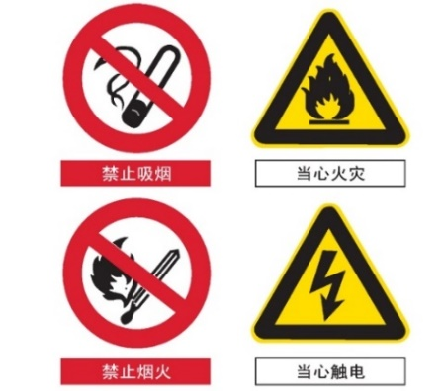
图1 横写的文字辅助标志
Figure 1. Horizontally-written supplementary signs for text
6.1.5竖写时，文字辅助标志写在标志杆的上部。禁止标志、警告标志、指令标志、提示标志均为白色衬底，黑色字。标志杆下部色带的颜色应和标志的颜色相一致。如图2。
When writing vertically, the text auxiliary sign is written on the upper part of the sign pole. Prohibition signs, warning signs, instruction signs, and information signs all have a white background and black words. The color of the color band at the lower part of the sign pole should be the same as the color of the sign.

6.1.6文字字体均为黑体字。
The text font is all bold.
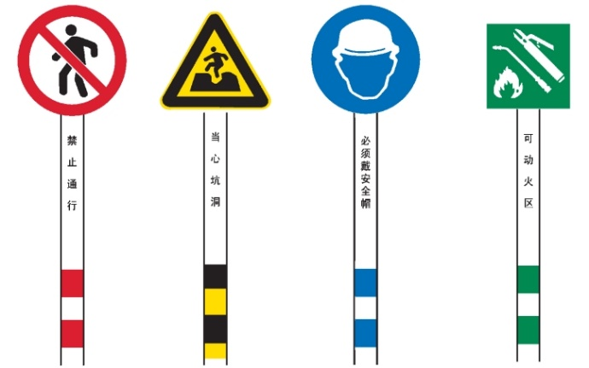
图2 竖写在标志杆上部的文字辅助标志
Figure 2. Text supplementary signs vertically written on the upper part of the sign post.

6.2 安全标志牌的要求Requirements for safety signs
6.2.1标志牌的衬边Signboard Border
安全标志牌要有衬边。除警告标志边框用黄色勾边外，其余全部用白色将边框勾一窄边，即为安全标志的衬边，衬边宽度为标志边长或直径的0.025倍。
Safety signboards should have a border. Except that the border of the warning sign is outlined in yellow, the rest are all outlined with a narrow white border, which is the border of the EHS sign. The width of the border is 0.025 times the side length or diameter of the sign.

6.2.2标志牌的材质Signboard Material
安全标志牌应采用坚固耐用的材料制作，一般不宜使用遇水变形、变质或易燃的材料。有触电危险的作业场所应使用绝缘材料。
Safety signboards should be made of durable materials. Generally, materials that deform, deteriorate or are flammable when exposed to water should not be used. Insulating materials should be used in workplaces with a risk of electric shock.

6.2.3标志牌表面质量Surface Quality of Signboards
标志牌应图形清楚，无毛刺、孔洞和影响使用的任何疵病。
The graphics on the signboards should be clear, without burrs, holes or any defects that affect use.

6.2.4标志牌设置的高度，应尽量与人眼的视线高度相一致。悬挂式和柱式的环境信息标志牌的下缘距地面的高度不宜小于2m；局部信息标志的设置高度应视具体情况确定。
The height at which the signboard is set should be as consistent as possible with the height of the human eye. The lower edge of the hanging and column-mounted environmental information signboards should be not less than 2m from the ground; the setting height of the local information signs should be determined according to the specific situation.

6.3 安全标志牌的型号选用 Selection of models for safety signs
6.3.1数据中心的入口处设6型或7型。
Set type 6 or 7 at the entrance of the data center.

6.3.2数据中心楼宇入口处、数据中心区域内设5型或6型。
Set type 5 or 6 at the entrance of the data center building and within the data center area.

6.3.3数据中心功能区域内（如柴油发电机房、电池间、机房等）设4型或5型。
Set type 4 or 5 within the functional areas of the data center (such as diesel generator rooms, battery rooms, computer rooms, etc.).

6.3.4局部信息（如设备表面等）标志牌设1型、2型或3型。
Set type 1, 2 or 3 for local information (such as on the surface of equipment) signboards.

6.3.5无论数据中心内或楼宇内，所设标志牌其观察距离不能覆盖全数据中心或全楼宇、功能区域面积时，应多设几个标志牌。
When the observation distance of the signboards set in the data center or building cannot cover the whole data center or building or functional area, several more signboards should be set.

6.3.6安全标志牌的型号选用可参考附件1。
The selection of safety signboard models can refer to Attachment 1.

6.4安全标志牌的使用要求The usage requirements of safety sign plates
6.4.1标志牌应设在与安全有关的醒目地方，并使大家看见后，有足够的时间来注意它所表示的内容。环境（此处描述的环境指工作环境，不是废气、废水等环境信息）信息标志宜设在有关场所的入口处和醒目处；局部信息标志应设在所涉及的相应危险地点或设备(部件)附近的醒目处。
Signboards should be set in conspicuous places related to safety so that people can notice them and have enough time to pay attention to the content they represent. Environmental (the environment described here refers to the working environment, not environmental information such as waste gas and waste water) information signs should be set at the entrances and conspicuous places of the relevant场所; local information signs should be set near the corresponding dangerous locations or equipment (parts) involved.

6.4.2标志牌不应设在门、窗、架等可移动的物体上，以免标志牌随母体物体相应移动，影响认读。标志牌前不得放置妨碍认读的障碍物。
Signboards should not be set on movable objects such as doors, windows and racks to avoid the signboards moving with the parent objects and affecting recognition. No obstacles that prevent recognition should be placed in front of the signboards.

6.4.3标志牌的平面与视线夹角应接近90°，观察者位于最大观察距离时，最小夹角不低于75°，如图3。
The angle between the plane of the signboard and the line of sight should be close to 90°. When the observer is at the maximum observation distance, the minimum angle should not be less than 75°.

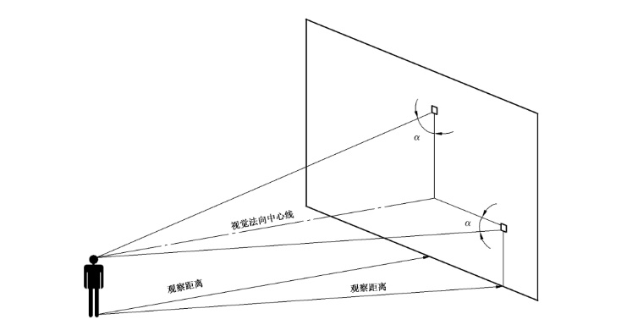
图3 标志牌平面与视线夹角α不低于75°
Figure 3: The angle α between the plane of the sign and the line of sight shall be not less than 75°.

6.4.4标志牌应设置在明亮的环境中。
Signboards should be set in a bright environment.

6.4.5多个标志牌在一起设置时，应按警告、禁止、指令、提示类型的顺序，先左后右、先上后下地排列。
When multiple signboards are set together, they should be arranged in the order of warning, prohibition, instruction, and information signs, from left to right and from top to bottom.

6.4.6标志牌的固定方式分附着式、悬挂式和柱式三种。悬挂式和附着式的固定应稳固不倾斜，柱式的标志牌和支架应牢固地联接在一起。
The fixing methods of signboards include attached type, hanging type and column type. The hanging and attached types should be fixed firmly without inclination, and the column type signboards and brackets should be firmly connected.

6.4.7其他要求应符合《公共信息导向系统设置原则与要求第1部分：总则》（GB/T 15566.1）的规定。
Other requirements should comply with the provisions of "Principles and Requirements for Setting of Public Information Guidance Systems - Part 1: General Principles" (GB/T 15566.1).

6.5 安全标志牌的检查和维修Inspection and Maintenance of Safety Signboards
6.5.1安全标志牌至少每半年检查一次，如发现有破损、变形、褪色等不符合要求时应及时修整或更换，检查表详见附件2。
Safety signboards shall be inspected at least once every six months. If any damage, deformation, fading or other non-compliance is found, they shall be repaired or replaced in a timely manner. For the inspection checklist, please refer to Attachment 2.

6.5.2在修整或更换激光安全标志时应有临时的标志替换，以避免发生意外的伤害。
When repairing or replacing laser safety signs, temporary signs shall be used for substitution to avoid accidental injuries.

6.6 工业管道标识Identification of industrial pipelines
6.6.1根据管道内物质的一般性能，分为八类，并相应规定了八种基本识别色和相应的颜色标准编号及色样，引用自《工业管道的基本识别色、识别符号和安全标识》（GB 7231）(见表1)。
According to the general properties of substances in the pipelines, they are classified into eight categories, and eight basic identification colors, corresponding color standard numbers and color samples are specified accordingly. This is quoted from "Basic Identification Colors, Identification Symbols and Safety Identification for Industrial Pipelines" (GB 7231) (see Table 1).

表1 八种基本色和色样及颜色标准编号
Table 1: Eight basic colors, color samples and color standard numbers
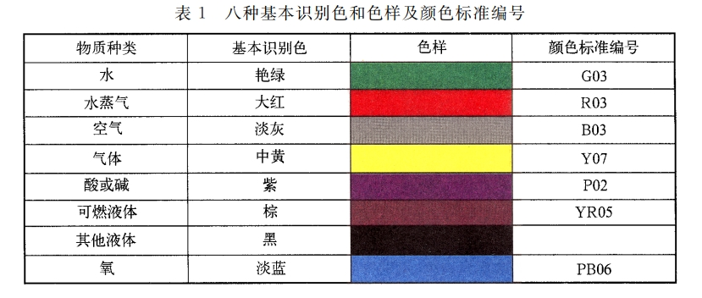
6.6.2基本识别色标识方法6.6.2 Identification methods for basic identification colors
工业管道的基本识别色标识方法,使用方应从以下五种方法中选择。
For the identification methods of the basic identification colors of industrial pipelines, the user shall select from the following five methods:
a)管道全长上标识；
Mark the entire length of the pipeline;
b)在管道上以宽为 150 mm 的色环标识；
Mark with color rings with a width of 150 mm on the pipeline;
c)在管道上以长方形的识别色标牌标识；
Mark with rectangular identification color plates on the pipeline;
d)在管道上以带箭头的长方形识别色标牌标识；
Mark with rectangular identification color plates with arrows on the pipeline;
e)在管道上以系挂的识别色标牌标识。
Mark with identification color plates hung on the pipeline.

6.6.3当采用 6.6.2 中 b), c), d), e)方法时,二个标识之间的最小距离应为10 m。
When methods b), c), d), and e) in 6.6.2 are adopted, the minimum distance between two identifications shall be 10 m.

6.6.4 6.6.2 中 c),d),e)的标牌最小尺寸应以能清楚观察识别色来确定。
The minimum size of the plates in c), d), and e) of 6.6.2 shall be determined according to the clear observability of the identification colors.
6.6.5当管道采用 6.6.2中 b),c),d),e)基本识别色标识方法时,其标识的场所应该包括所有管道的起点、终点、交叉点、转弯处、阀门和穿墙孔两侧等的管道上和其他需要标识的部位。
When the basic identification color identification methods in b), c), d), and e) of 6.6.2 are adopted for pipelines, the identification locations shall include the starting points, end points, intersections, turning points, both sides of valves and wall-penetrating holes of all pipelines, as well as other parts that need to be identified.
6.6.6工业管道的识别符号由物质名称、流向和主要工艺参数等组成,其标识应符合下列要求:
The identification symbols of industrial pipelines consist of the substance name, flow direction, and main process parameters, etc., and their identifications shall meet the following requirements:
- 物质名称的标识Identification of substance names
- 物质全称。例如：冷却水、柴油等。
The full name of the substance. For example: cooling water, diesel, etc.
b)化学分子式。例如：H₂O、柴油等。
Chemical formula. For example: H2O, diesel, etc.
- 物质流向的标识Identification of substance flow direction
- 工业管道内物质的流向用箭头表示，如图4中的a)。如果管道内物质的流向是双向的,则以双向箭头表示图4 中b)。
The flow direction of substances in industrial pipelines is indicated by arrows, as shown in Figure 4 (a). If the flow direction of substances in the pipeline is bidirectional, it is indicated by a bidirectional arrow, as shown in Figure 4 (b).
- 当基本识别色的标识方法采用6.6.2中的d)和e)时,则标牌的指向就作为表示管道内的物质流向，见图4中的 c)和 d),如果管道内物质流向是双向的,则标牌指向应做成双向的，见图4中的 e)。
When the identification methods of basic identification colors adopt d) and e) in 6.6.2, the direction of the plate shall be regarded as indicating the flow direction of substances in the pipeline, as shown in Figure 4 (c) and (d). If the flow direction of substances in the pipeline is bidirectional, the direction of the plate shall be made bidirectional, as shown in Figure 4 (e).
- 物质的压力、温度、流速等主要工艺参数的标识,使用方可按需自行确定采用。
Identification of main process parameters such as pressure, temperature, and flow velocity of substances can be determined by the user as required.
- 字母,数字的最小字体,以及箭头的最小外形尺寸,应以能清楚观察识别符号来确定。
The minimum font size of letters and numbers, as well as the minimum external dimensions of arrows, shall be determined according to the clear observability of the identification symbols.
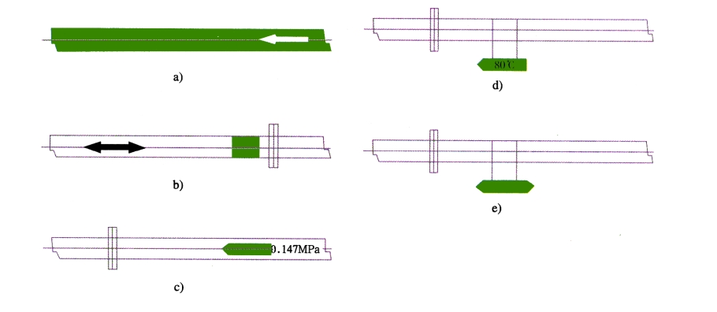
图4 基本识别色和流向、压力、温度等标识方法参考图
Figure 4: Reference diagram for identification methods of basic

6.7 环境管理相关标识Identification Related to Environmental Management
6.7.1环境管理相关标识要求，详见《废气排放管理制度》、《废水管理制度》、《噪声管理制度》、《危险废物管理制度》等。
For the requirements of identification related to environmental management, please refer to the “Waste Gas Emission Management System”, “Waste Water Management System>, <Noise Management System”, “Hazardous Waste Management System”, etc.

6.8 职业健康相关标识Identification Related to Occupational Health
6.8.1 职业健康相关标识详见《职业健康管理制度》。
For identification related to occupational health, please refer to the “Occupational Health Management System”.

6.9 消防管理相关标识Identification Related to Fire Protection Management
6.9.1 消防管理相关标识详见《消防安全管理制度》。
For identification related to fire protection management, please refer to the “Fire Safety Management System”.

6.10 危险化学品相关标识Identification Related to Hazardous Chemicals
6.10.1 危险化学品相关标识详见《危险化学品管理制度》。
For identification related to hazardous chemicals, please refer to the “Hazardous Chemicals Management System”.

6.11 电气管理相关标识Identification Related to Electrical Management
6.11.1 电气管理相关标识详见《电气安全管理制度》、《变电站安全管理制度》。
For identification related to electrical management, please refer to the “Electrical Safety Management System” and “Substation Safety Management System”.

6.12 沟通与培训Communication and Training
6.12.1确保将本管理制度相关要求在数据中心内部进行告知和沟通。
Ensure that the relevant requirements of this management system are notified and communicated within the data center.

6.12.2上海浦江数据中心应当做好危险源识别与风险评估，识别出EHS标识。
SHANGHAI PUJIANG Data Center shall conduct hazard identification and risk assessment to identify EHS identifications.

6.12.3各部门/岗位/业务线人员定期对EHS标识进行检查及维护，及时更新EHS标识，以确保符合最新相关法规要求。
All departments/ positions/ business lines shall regularly inspect and maintain EHS identifications and update them in a timely manner to ensure compliance with the latest relevant laws and regulations.

7 附件Attachments
- 附件1：安全标志牌尺寸
Attachment 1: Dimensions of Safety Signboards
- 附件2：安全标志牌检查表
Attachment 2: Safety Signboard Inspection Checklist
附件1：安全标志牌尺寸 [引用自《安全标志及其使用导则》（GB 2894）]
Attachment 1: Dimensions of Safety Signboards [Quoted from "Safety Signs and Their Usage Guidelines" (GB 2894)]
型号  Model | 观察距离L（m）  Observation distance L (m) | 圆形标志的外径（m）  Outer diameter of circular signs (m) | 三角形标志的外边长（m）  Outer side length of triangular signs (m) | 正方形标志的边长（m）  Side length of square signs (m)
1 | 0＜L≤2.5 | 0.070 | 0.088 | 0.063
2 | 2.5＜L≤4.0 | 0.110 | 0.1420 | 0.100
3 | 4.0＜L≤6.3 | 0.175 | 0.220 | 0.160
4 | 6.3＜L≤10.0 | 0.280 | 0.350 | 0.250
5 | 10.0＜L≤16.0 | 0.450 | 0.560 | 0.400
6 | 16.0＜L≤25.0 | 0.700 | 0.880 | 0.630
7 | 25.0＜L≤40.0 | 1.110 | 1.400 | 1.000
注：允许有3%的误差。
Note: An error of 3% is allowed.

附件2：安全标志牌检查表
Attachment 2: Safety Signboard Inspection Checklist
安全标志牌区域  Safety signboard area | 检查内容  Inspection content | 检查日期  Inspection date | 检查结果  Inspection result | 是否更换完成  Whether replacement is completed
柴油发电机房  Diesel generator room | - 是否有破损  Whether there is damage  - 是否有变形  Whether there is deformation  - 是否有褪色  Whether there is fading  - 是否有掉落  Whether there is falling off
日用油箱间
Daily fuel tank room
冷机房
Chiller room
蓄冷罐
Cold storage tank
柴油储罐区
Diesel storage tank area
配电室
Distribution room
电池间
Battery room
其他区域……
Other areas…
注：Note:
- 检查结果填写：破损、变形、褪色、掉落
Fill in the inspection result: damage, deformation, fading, falling off.
2.至少每半年检查一次，留存好检查、维修更换记录。
Inspect at least once every six months and keep good records of inspection, maintenance and replacement.

